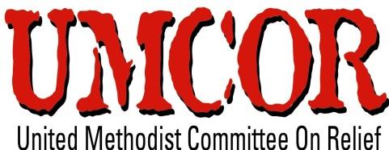
Services Required for supply of Hygiene Kits
UMCOR’ Haiti mission is providing emergency response, early recovery and transitional development assistance in the affected regions of Haïti. UMCOR innovatively bridging the gap between immediate relief and long-term community development program by partnering with communities on front lines. UMCOR Haiti is implementing “Provision of Integrated Services around New Settlement” Program through financial assistance of United States Agency for International Development (USAID) in Haut Damier, Municipality of Cabaret. UMCOR Haiti intends to purchase 3000 Hygiene kits for providing to vulnerable communities in the Muncipality of Cabaret.
Description:
UMCOR Haiti is seeking services of supplier who can provide Hygiene Kits within agreed time frame.
Specification:-
Each Hygiene Kit should comprise of following items as follow;
- Soap for laundry and personal hygiene (Sphere recommends 250gms bathing soap per person per month and 200gms laundry soap per person per month)
- Jerry can Water collection AND storage containers (Sphere specifies at least 2 water collecting containers of 5 gallons)
- Aquatabs 10 Numbers
- Disposable sanitary towels for women
- Razor blades
- Nail clippers,
- Comb
- Shampoo regular
- Toothbrush and toothpaste
- Insecticide Treated Net
- ORS sachets

Bids can be submitted in a sealed envelope with in 05 days at following address:
UNITED METHODIST COMMITTEE on RELIEF (HAITI)
P.O Box 15562
HT 6140
Port- au-Prince, Haïti
Or
Sealed bids can be submitted by hand at
16, Delmas 54 office UMCOR-Haiti For question & clarification, please, contact: procurement@umcor-haiti.or g

