Tender for construction Latrine Block Institution L’Espoir
- Adresse: Institution L’Espoir, Pernier 16, bois Greffin. Local Eglise croissade Evangelique.
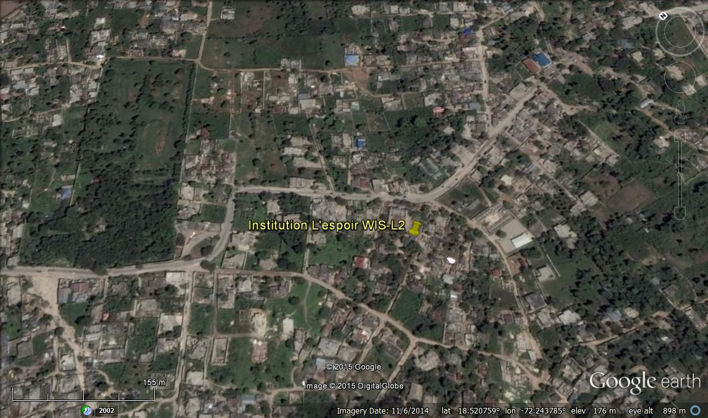
- Accountability and Responsibilities
The project includes construction of a 7 stance latrine, urinal, hand washing station, gutters, soaker pit, and reservoir.
- Site Visit
Interested contractors must attend a compulsory site visit starting at:
UMCOR Cabaret office at 16, Delmas 54,
11 am, Thursday, December 3, 2015 or 11 am Friday, December 4, 2016 (exact date will be given to bidders when they register)
ONLY THOSE BIDDERS ATTENDING THE SITE VISIT WILL RECEIVE BID DOCUMENT PACKAGE
Note no questions or meetings will be allowed before the compulsory site visit dates.
REGISTER FOR SITE VISIT AT: UMCOR Offices 16, Delmas 54 or by email at emorales@umcor-haiti.org, anytime before 2 pm December 2, 2015 – sign-up sheet at gate.

- Timeframe
Tender Closes: 10:30 am, Friday, December 18, 2015
Opening of Bids: 12:30 pm, Friday, December 18, 2015
- Instructions for Submission of Bids
Interested contractors must provide a bid package containing the following information in English. Please note that incomplete applications will not be considered.
  - The quantities have already been calculated, so please add unit costs and total costs only in USD. Unit and lump sum costs should include all costs, including materials, labor, profit, overhead, all applicable taxes, fees, transportation, testing and all other costs.
  - Financial Statement - Contact information of your company on letterhead, including contact names, address, country registration form with the organization’s fiscal identification number included, and bank information, including the name of bank, account number, sort code and swift code
    - Statement of Financial Position as of September 2015 (Bilan)
    - Statement of Profits and Loses for the Fiscal year October 2015 to September 2015. (Etat de Resultat)
  - Contact details for at least 3 organizations for whom you have completed similar work and authorization to contact them. Specify what the work you did for each of these organizations.
  - CVs of key personnel (engineers and technicians) on your staff and the number of workers you plan to employ on the project.
  - A detailed work plan showing the estimated completion date, tasks, equipment to be used, workers to be employed for each phase, etc.
  - Submit the Quitus, Droit de License, and income tax number required by law.

