===================================================================
RFQ JRM-19-003
Under Contract # OAA-I-14-00049/720521
Issue date: September 25, 2019
Activity: Renting a storage container for CTE Jeremie

Modification # 1
Modification date: October 2, 2019
====================================================================================
The purpose of modification #1 to RFQ-JRM-19-003 RENTING A STORAGE CONTAINER FOR CTE JEREMIE is as follows:
- Respond to the questions submitted by the potential offerors for this RFQ
- Extend the due date to submit the proposal/quote for this RFQ

- Responds to the questions submitted by the potential offerors for this RFQ:

Q: We would like to have information (photos, plans) of the space where the container will be installed in order to provide the handling (machine or arm of men) and the appropriate costs for the installation.
A: Below are annexed the photos and the plan as requested.

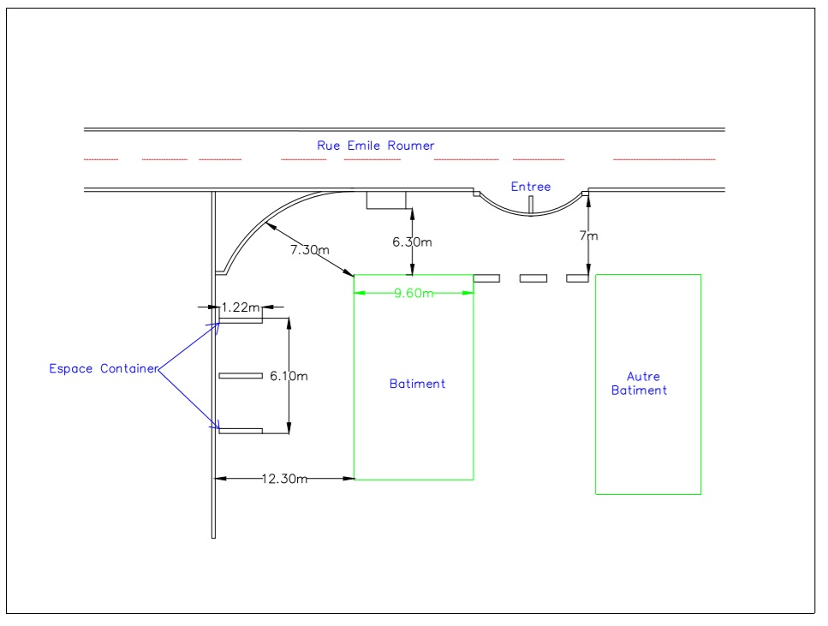

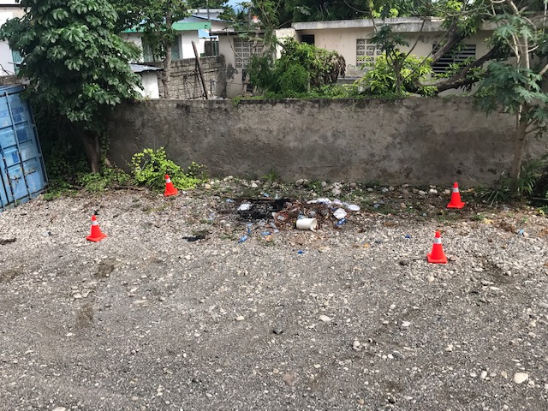

- Extend the deadline for submitting the proposal/quote of the RFQ

Due to the political and security situation of the country, several companies have closed their doors because of demonstrations and strikes. To compensate for the closed days and to give more time to the suppliers to answer very well to the RFQ, DAI decide to extend the deadline until October 9th, 2019.

All others content of the solicitation referenced above not specified in this modification, remain unchanged.
RFQ link: https://www.jobpaw.com/pont/entreprises.php?ido=1990
End of modification #1.

