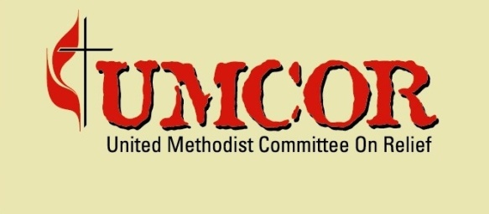

TOR for UMCOR Employee Insurance
Introduction
The United Methodist Committee on Relief (UMCOR) is a United States based not-for-profit organization which is registered as a non-governmental organization (NGO). UMCOR has a long operational history in Haiti. Across all its programming (livelihoods; water, sanitation and hygiene; shelter and reconstruction), UMCOR Haiti supports community engagement. This involves extensive community-based consultation and participation as well as close coordination among project partners including the Government of Haiti (GoH) and donor partners. The overarching objective of UMCOR Haiti’s efforts is to support the Government of Haiti (GoH) in implementing sustainable post-earthquake reconstruction and development. The UMCOR Haiti Strategy which covers the period of 2013-2017 takes into account Haiti’s development challenges pre-earthquake yet focuses on reconstruction and projects adequate for reconstruction given the changes in context, content, and focus of the Government of Haiti’s (GoH) “Build Back Better” agenda.
The Purpose: Ensure that the employees included their dependent have a good health care system, the UMCOR-HAITI seeks an institution/company to provide an Health Insurance, witch one can share with the office the high quality services by following the details listed below.
Information requirements:
- Inclusive information’s containing contact number, address, email of the institution
- Copy of patente, Copy of quitus, vendor registration form filled
- Complete information about health and life insurance plans
- Plans eligible conditions
- Service Offer
- Plans advantage Information: Accident Cover/ Funeral Cover/ Maternity and Health Cover
- Steps to get/use the Medical service
- General exclusion
- Network health informations
- Demonstrated relevant experiences in life and health insurance
- Financial proposal: detailed quotation with price per plan (single and family plan)
- Should have at least 5 years of experience in dealing same assignments
- Capacity to work collaboratively with customers…
Service Quality Requirements:
- Insurance company should be ready to provide on a regular basis accessible an updated list of it medical Network (hospital/doctors, pharmacies…)
- Insurance company should be able to provide on a regular basis an updated list of the benefits
- Insurance company should be able to follow up with the employees reimbursements in a deadline not up than 2 months
- Insurance company should be able to provide training for the staff/HR Responsible two (2) or three (3) times per Year or if needed
- Insurance company should be able to send by email the monthly quotations for payment follow up
- Changes or modifications requested from the UMCOR office should be effective automatically
- Insurance should be able to share with UMCOR office any changes done by the company.
Submission of Bids:
Bids can be submitted in a sealed envelope to the following address:

UNITED METHODIST COMMITTEE on RELIEF (HAITI):
P.O Box 15562, HT 6140, Port-au-Prince, Haïti, or sealed bids can be submitted by hand at 16, Delmas 54 office UMCOR- Haïti. (separate box is designated for submission of Bids)
The contractors are requested to submit seals bids before 12h on Wednesday 16th, 2016. It is pertinent that bids should be submitted in English.
For any question and clarification, please contact: procurement@umcor-haiti.org

